/\*I use file ClearingHouse.xml to record information of traders and their current orders

\* I use file OrderHistroy.xml to record all submitted orders

\*/

Initial ClearingHouse.xml

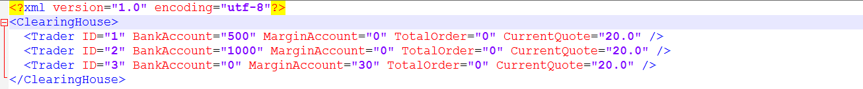

Initial OrderHistroy.xml



Tests:

Required Margin= quote price\*original order number\*0.02\*0.9+quote price\*new order number\*0.02

1, submit one new market order

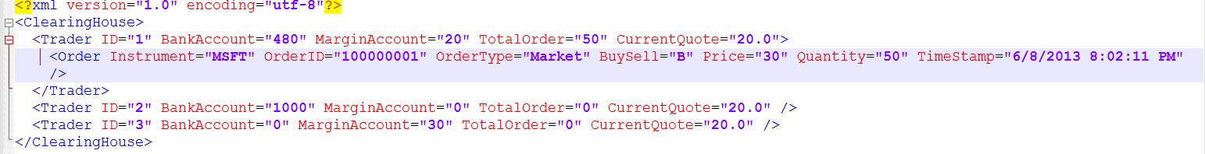

2, match market order; partial match; for market order, attribute “price” means nothing

Before match

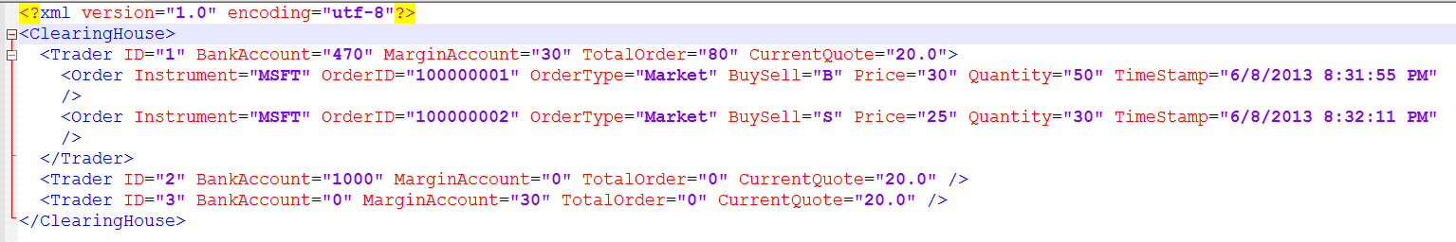

After match

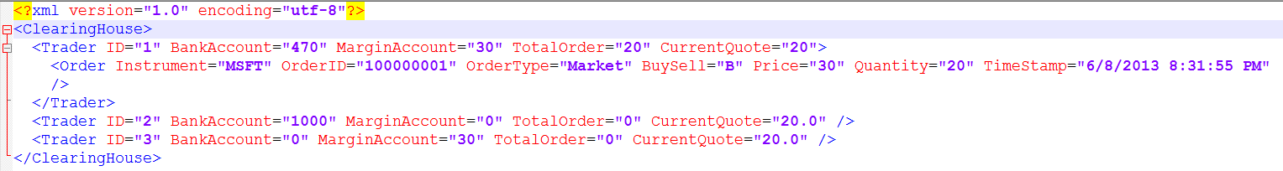

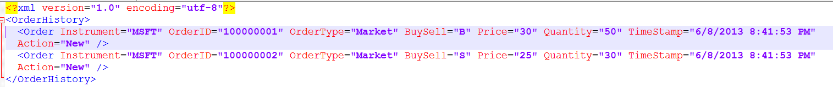

3, submit one new Limit order

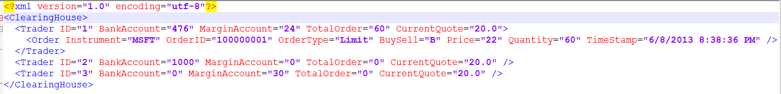

4, match limit order; fully match; current Quote updated

Before match

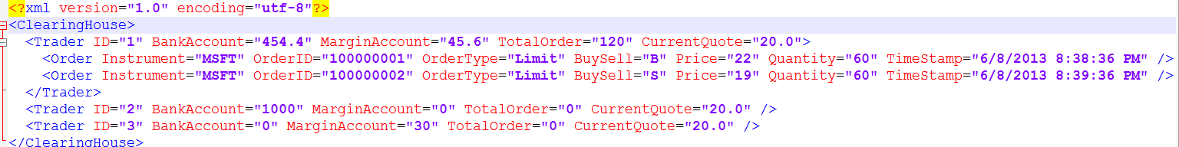

After match

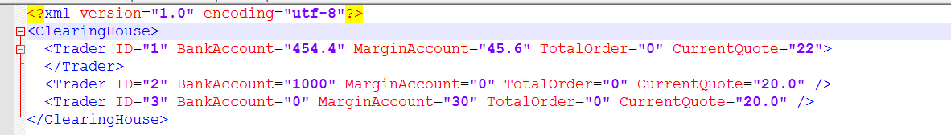

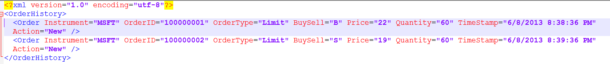

5, submit stop order

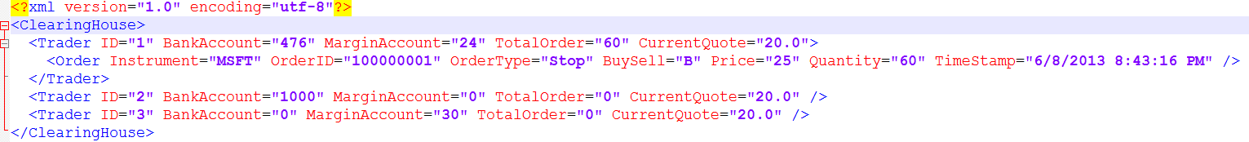

6, stop order become market order when quote price meet requirement

Before quote price change

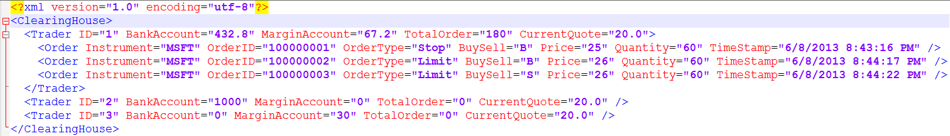

after quote price change

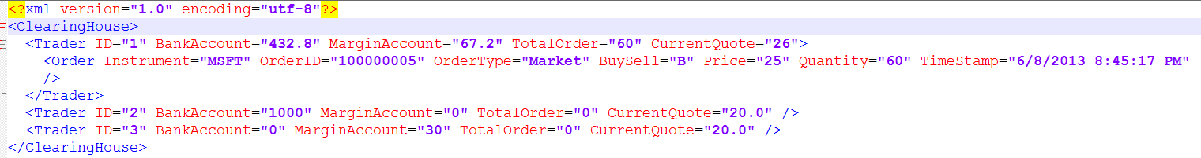

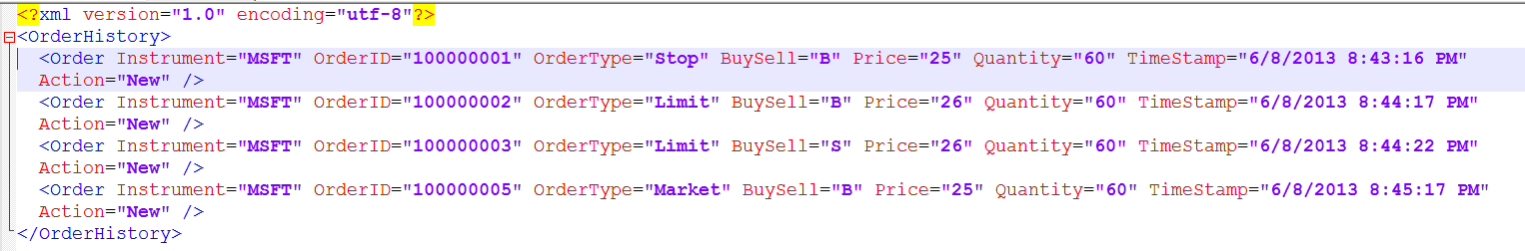

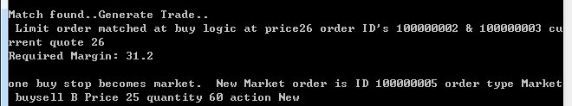

6, update order

Before update

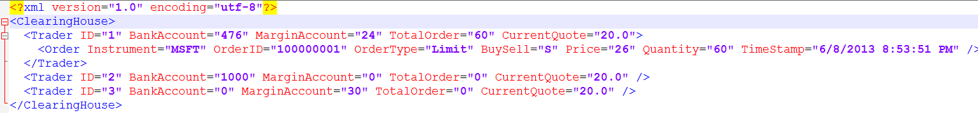

After update

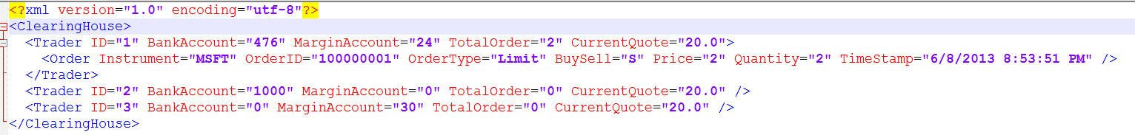

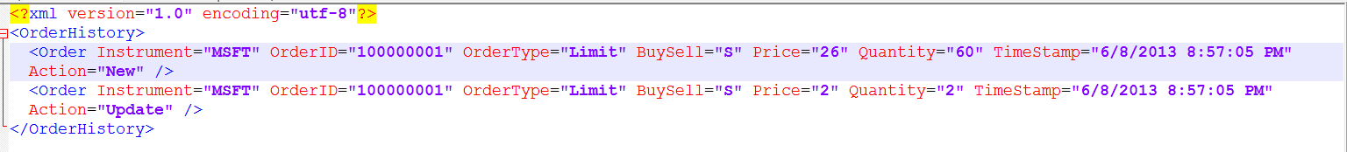

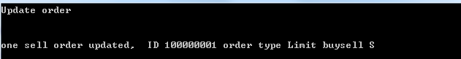

7, cancel order

Before cancel



After cancel

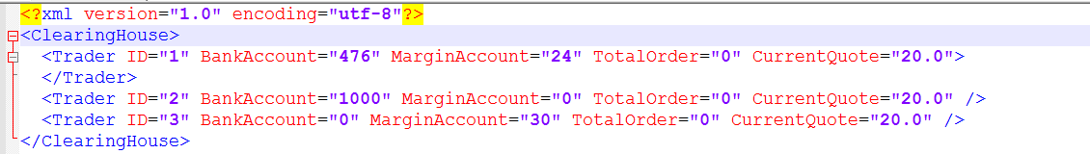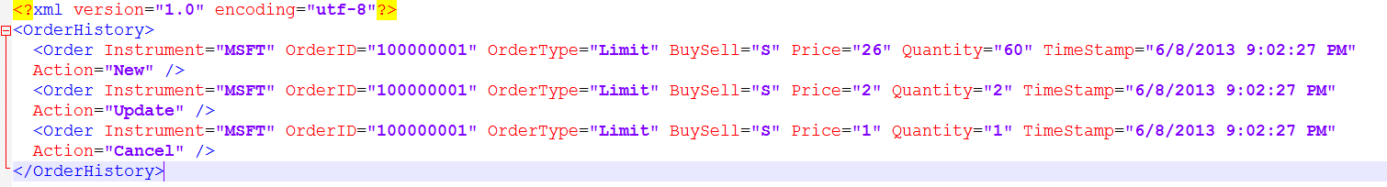

8, if margin not enough, new order rejected

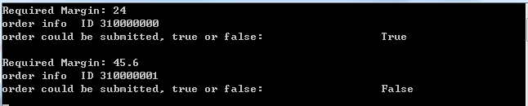

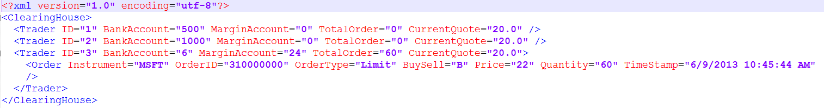

9, if update order lead to lack of margin; update order rejected

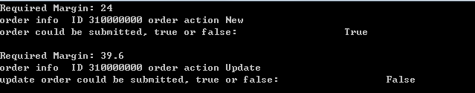

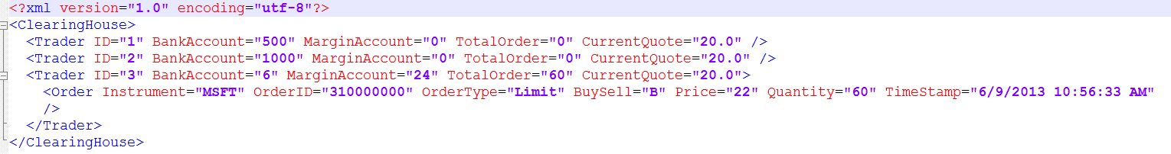

10, if order quantity larger than 100, reject

if (order.Quantity > 100) { return false; }//also we could set other criteria

11, if quote updated and margin is not enough, clear all position.

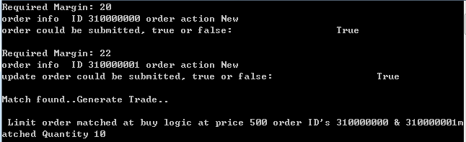

Before clear

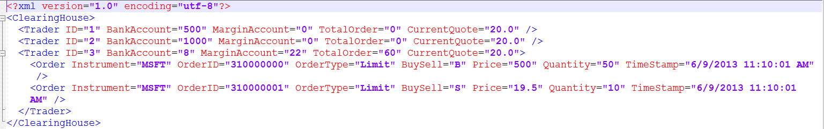

After clear

